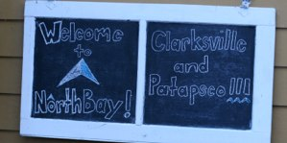

Introduction 1

Outdoor Ed. Article Natalie Cho 2

Sports Cruz Hanson 3

Harvest Fest Sanam Patel 4

Gifts to Give Amy Li 5

Recipe for a Mummy Krisana Goel

Misc. Articles Krisana Goel, Natalie Cho, Amy Li 6

Teacher Survey Sabrina Dineshkemar 7

Entertainment Naomi Hess 8

Word Search Sanam Patel 9

Authors Note Megan Rabe 10

Conclusion 11

#### Holidays Coming Up This Month

##### Hanukkah

##### Christmas

##### Kwanzaa

12/26- 1/1

12/20- 12/28

12/25

A week-long celebration of African culture and traditions

A celebration of the birth of Jesus Christ, the prophet for Christians

A Jewish festival, lasting 8 nights, that celebrates the miracle of the oil

# Table of Contents

December 14th: Interim Progress Reports

December 15th: Concert - Choir/Guys and Dolls

December 20: Spelling Bee!!!

Winners in Mrs. Barkley’s class:

A: Nehemiah Seblu

B: Megan Rabe

C: Max Xuan

D: Joe Fields

E: Lexi Skochinski

Winners in Mrs. Cohee’s class

Victoria Ha

Winners in Mrs. Puryear’s class

B: Patrick Grimsley

C: Joey Egert

D: Cruz Hanson

### Important Events

Fall 2011

Edition 2

During October 17-20, 2011, the 6th graders at Clarksville Middle School went to Outdoor Ed. at NorthBay camp. This was Clarksville’s ﬁrst time going to Northbay, so no one was quite sure what to expect. Mrs. Holihan noted that this camp was high quality and everyone wondered if it would live up to its new expectations. Apparently, it did! The camp had fun activities such as zip lining, rock climbing, ropes course, a giant swing, and kayaking. Many people were scared to try some of these, but most overcame their fears and did them. Everyone in my cabin enjoyed doing all of them, including me! NorthBay also made learning fun by making everything hands-on. For example, several classes learning about wetlands got to go into NorthBay’s own wetlands. Even though everyone got mucky and wet, everyone had fun catching fish, frogs, lots of tadpoles, and bugs.(Which were released unharmed back into the wetlands.) NorthBay also had their own little show every night called “NorthBay LIVE!” They had catchy music that everyone danced to, their own band called Inﬂuence, which got a standing ovation, and fun little skits that taught important lessons on friendship and being eco-friendly. One of the nights NorthBay hosted their very own talent show that consisted of juggling, jump roping, guitarists, pianists, drummers, dancers, comedians, and lots of singers! Some groups had a course called Food 101, where they had to clean up the tables at the dining hall after everyone had eaten. For those people, scraping out half-eaten food out of dirty bowls was probably the low point of their trip. One other low point was that it rain on one of the days, so classes had to miss out on ﬁshing, clamming, hiking, and other outdoor activities, though it was out of everyone’s control. Overall, NorthBay was fun and people got to make new friends, overcome their fears, be more independent, learn how to be eco-friendly, and learn about how their actions not only affect them, but the people and environment around them. It seems very likely that Clarksville will be coming back here next year!

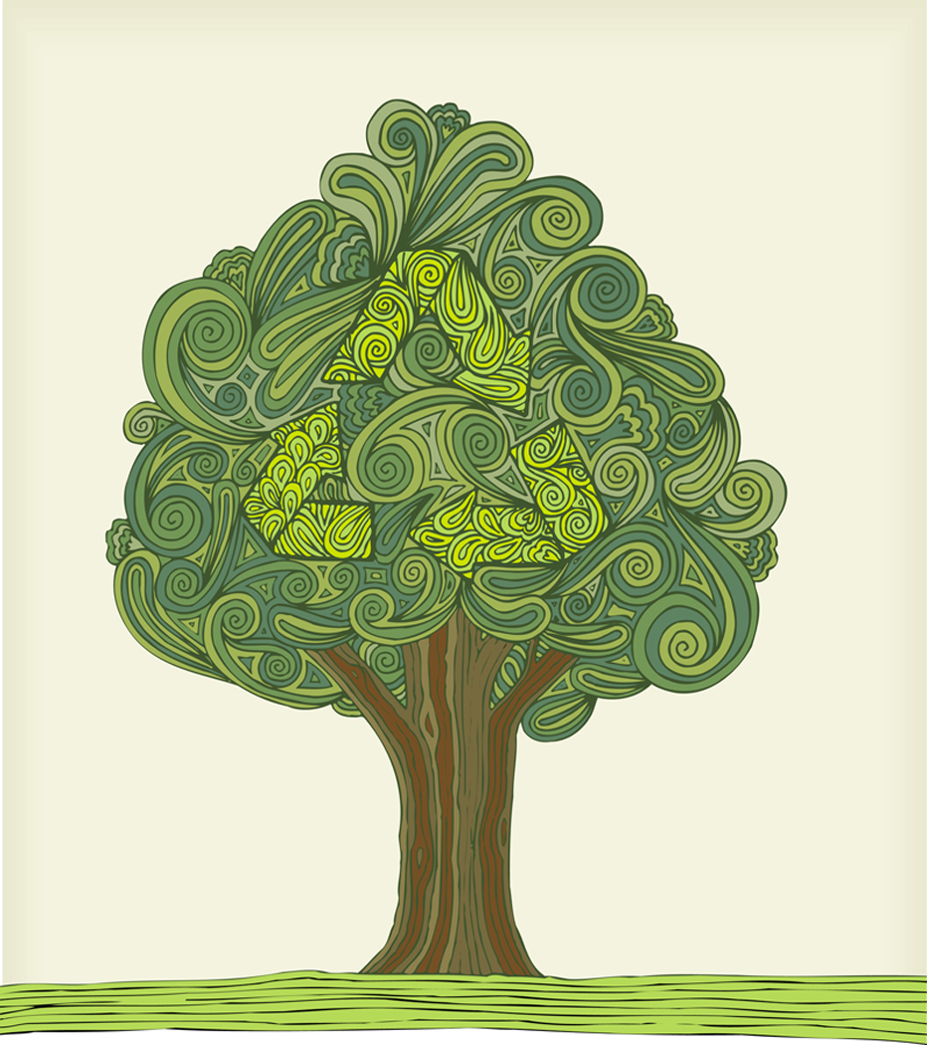

C:\Program Files\Microsoft Office\MEDIA\CAGCAT10\j0298897.wmf

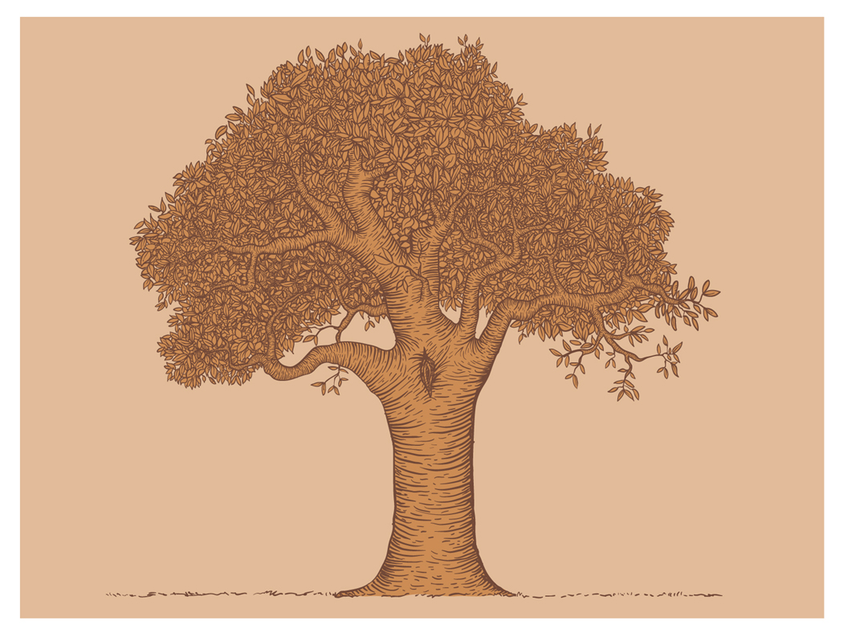



Outdoor Ed at NorthBay

By: Natalie Cho

By: Natalie Cho

By: Natalie Cho

B

B

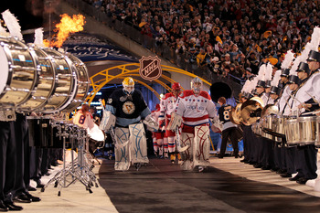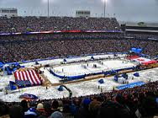

C:\Users\jeffli\AppData\Local\Microsoft\Windows\Temporary Internet Files\Content.IE5\3ZSD9DKX\MC900239505[1].wmf

C:\Users\jeffli\AppData\Local\Microsoft\Windows\Temporary Internet Files\Content.IE5\3ZSD9DKX\MC900239505[1].wmf

Sports

By: Cruz Hanson

The NHL is switching up the divisions next year, so the teams will play each other more often. The Penguins and the Capitals will play each other more than they do in the regular season.

The **NHL Winter Classic** is an annual event held by the national hockey league (NHL) on New Year’s Day where regular-season games are played outdoors, in areas hosted by NHL teams. Though largely derived from the heritage classic outdoor game held in Edmonton in 2003, the Winter Classic has so far only featured US-based teams, while the Heritage Classic involves Canada-based teams. The first Winter Classic was held in 2008.

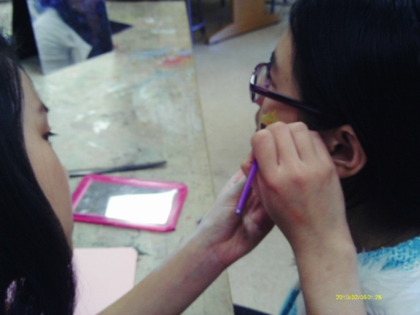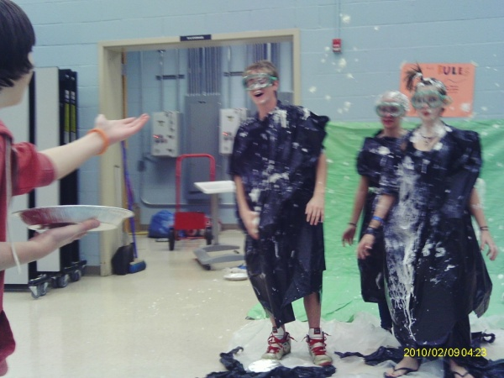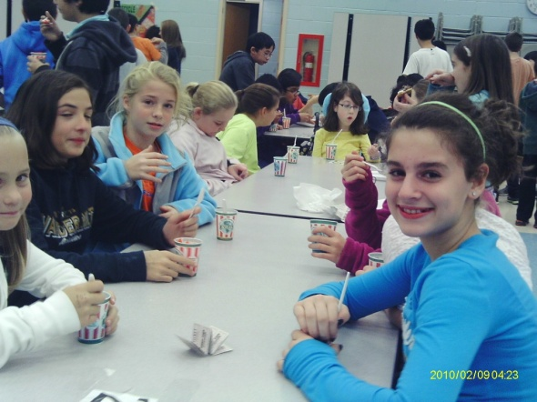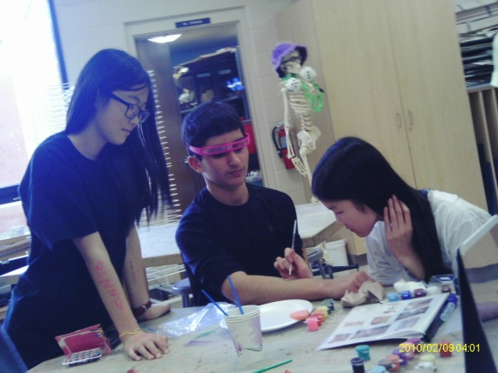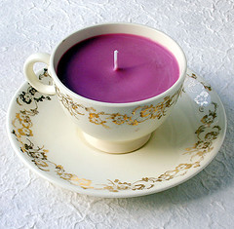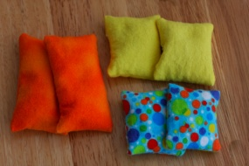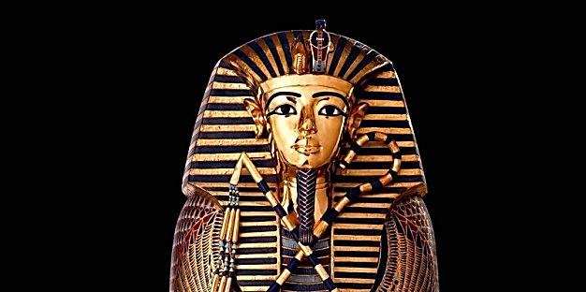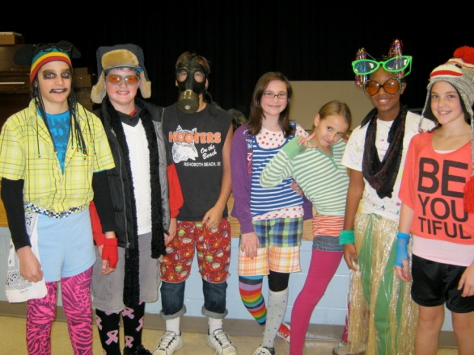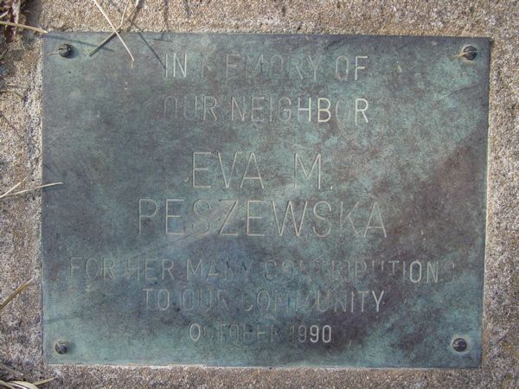

*Note: 8th graders are having technical difficulties. Anyone who had their picture taken at Harvest Fest can stop by Mrs. Sheetz room to check. Hopefully, the pictures will be ready soon.

Hey, 6th graders. Did you have fun at Harvest Fest? Well, I interviewed an anonymous source. Here are some of her favorite games and activities from Harvest Fest.

Q: **Were the 8th graders that were running the activities mean?**

A: For the most part, no, they were not mean.

Q: **What were your top 3 favorite activities?**

A: Coke And Pepsi, Cow Pies, And Cake Walk

Q: **Did you have any Rita’s or pizza?**

A: I had Rita’s only.

Q: **How much money did you bring for harvest fest and was it enough to pay for your activities (fun)?**

A: I brought in $5 and spent every single ticket (penny).

Q; **Did you win and prizes? If yes, how many?**

A: Yes, I won about 9 or 10 prizes.

Q: **Did you get any pictures taken?**

A: Yes, I got one picture taken with 6 other people. It was very funny, but sadly, I forgot to pick it up.*

Q: **Overall, was your first Harvest Fest experience great, good, could be better, or absolute horror?**

A: My first harvest fest experience was a fairly good one.

# Harvest Fest

Interview with an anonymous source

By: Sanam Patel

# Gifts to Give

By: Amy Li

One of the hardest things about the holiday season is deciding what presents to give. It’s extremely easy to make simple, homemade gifts that people will love.

1. Create a [**secret hollow book**](http://how2dostuff.blogspot.com/2006/02/how-to-make-secret-hollow-book.html). Buy a cheap, not-so-good book at a nearby bookstore. Glue the pages together, use a knife to hollow out the center of the book. Now the recipient can store things in it.
2. Make **teacup candles**.

Materials: craft-store wicks, wax (or old candles) that can be melted down, and old teacups

Optional: fragrance

Instructions: Melt the wax in a double boiler, add fragrance if wanted, then support the wick standing in the teacup while carefully filling the cup with wax. Let the wax cool. Add more wax if necessary or for a darker shade.

1. Give the gift of warmth with a **homemade hand warmer**. First, make a 4 inch by 4 inch small bag (any shape you want), but leave one side open. Fill the 3/4 of the bag with [ceramic pie weights](http://www.amazon.com/exec/obidos/ASIN/B0011YKPUE/ref=nosim/getrichslo-20/) or, even simpler, uncooked rice.

To use: Microwave them on medium high for 2 minutes. They should stay warm for about 30 minutes.

|  |
| --- |
|  |

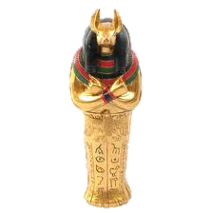

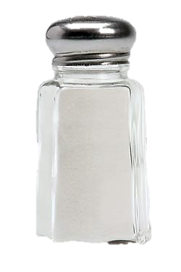

* salt
* canopic jars
* lots of linens

Note: this is for already dead people please do not do this to siblings

# Recipe for a Mummy

1. Dry out the body with salt.
2. Remove internal organs.
3. Wrap body in linen.
4. Have fun with your mummy.

###### By: Krisana Goel

On December 1st, the 6th, 7th, and 8th grade debate teams went to Bonnie Branch Middle School to participate in a debate on whether or not electronics should be allowed in school for educational purposes. Unfortunately, Clarksville Middle lost to Elkridge Landing.

Mr. Ilenda’s mom was the coach for the other team!

## Debate

By: Amy Li

On November 30th, Clarksville had their Wacky Tacky day!!! Everyone looked great, wearing colorful hats, socks, shirts, pants, and anything else you could imagine!!!

## Wacky Tacky Day

By: Natalie Cho

What do you think of when you think of MUMMIES? You probably think and some really old dead person wrapped in toilet paper! Am I right? But a mummy doesn’t have to be wrapped. A mummy is defined as a persevered body with some hair, skin and muscles. They were found all over the world, including Europe, Asia, Africa, Oceania and South America. Scientists can now see not only what’s inside the wrapping, but also now what’s inside the body of the mummy. Also, mummies can be human made Egyptian mummies are one example.

## Mummy World

## by Krisana Goel

There is a marker near the school’s front parking lot.

It says:

In Memory of

Our Neighbor

Eva M. Peszewska

For Her Many Contributions

To Our Community

October, 1990

If you know anything about this, email [mvinje@hcpss.org](mailto:mvinje@hcpss.org).

CMS Mystery

By: Amy Li





# Mysterious Teacher Survey

By: Sabrina Dineshkumar

Can you guess which teacher this is by using these facts below…?  If you think you know who it is write to us at… [clarksvillecomet@gmail.com](mailto:clarksvillecomet@gmail.com), with your best guess by December 16th to ***win a prize! Remember to put your name on your answer or you will not be given credit!***   
  
Favorite color: Yellow  
  
Favorite T.V. show: Modern Family  
  
Favorite Book: usually the last one finished  
  
Favorite movie: The Silence of the Lambs  
Favorite Food: crabs  
  
Favorite hobby: shopping  
  
Favorite Season: Summer  
  
Favorite Animal: cat  
  
Favorite Football team: Redskins!  
  
Favorite Baseball team: Orioles!

Favorite Time of Day: Late Afternoon  
  
Favorite Fast-Food Restaurant: Chick Fil-A  
  
Favorite Candy: Snickers  
  
Pet: Cat  
  
How long they have been teaching: 13 years



**LADY GAGA MAKES AN ANTI- BULLYING FOUNDATION**

Lady Gaga is famous for her crazy outfits and electronic songs. She is also an advocate against bullying. That is she, with the support of MacArthur Foundation and Harvard University, has launched a foundation against bullying. What better name for it than the Born This Way Foundation! This foundation will focus on many issues, including self-confidence and youth empowerment. Lady Gaga and her mom, Cynthia Germanotta, will direct the organization that will open next year.

**X FACTOR CONTESTANTS CAUGHT LIP-SYNCHING**

Many of you have heard about the new singing competition, the X Factor. This show features Simon Cowell, L.A. Reid, Nicole Scherzinger, and Paula Abdul as judges, or as they say, “mentors.”Simon mentors the girls, L.A. is in charge of the boys, Nicole looks over the over 30s, and Paula is a role model to the groups. On Thursday, November 3, there was a result show on FOX. In the opening number, which was “Without You” by Usher and David Guetta, Leroy Bell was clearly singing without the microphone to his mouth. He was caught... red-singing! Later on in the show, the two bottom acts battled for their survival. It was the Stereo Hogzz against InTENsity, two of Paula’s groups. A few members of Stereo Hogzz were also singing without a mic. They ended up staying in the competition. Simon Cowell spoke out later last week, and claims that they lip-synched so they could use better choreography. Do you think that contestants should lip-synch so they can dance better?

Entertainment

By: Naomi Hess

**Animal Word Search**

**By: Sanam Patel**

There are 35 words (animals) in this word search. Try to find them all.

|  |  |  |  |  |  |  |  |  |  |  |  |  |  |  |
| --- | --- | --- | --- | --- | --- | --- | --- | --- | --- | --- | --- | --- | --- | --- |
| P | V | S | G | S | L | G | E | C | S | R | A | S | R | S |
| T | O | I | N | I | N | L | O | H | U | A | N | K | C | X |
| A | P | R | Z | I | E | A | A | D | P | C | A | U | O | R |
| N | E | A | C | P | U | T | K | M | Y | C | U | N | W | E |
| D | R | N | H | U | E | G | O | E | T | O | G | K | A | G |
| D | E | A | I | E | P | U | N | U | A | O | I | A | L | I |
| T | N | E | H | U | S | I | H | E | L | N | D | A | L | T |
| T | A | C | R | E | G | Y | N | M | P | U | T | R | I | S |
| G | I | R | A | F | F | E | A | E | C | U | A | D | R | O |
| Q | R | E | T | S | M | A | H | K | O | B | C | V | O | S |
| H | I | P | P | O | P | O | T | A | M | U | S | A | G | T |
| G | L | I | O | N | E | S | S | Z | X | L | M | R | Q | R |
| R | U | A | S | O | N | I | D | W | I | L | D | K | I | I |
| R | E | V | A | E | B | R | H | I | N | O | S | S | E | C |
| E | S | O | O | G | N | O | I | L | P | U | M | A | S | H |

**I Bet YOU didn’t know these Facts about Thanksgiving**

You probably think of Thanksgiving as a time where you give thanks, get stuffed

with pumpkin pie and turkey, and spend time with friends and family. Thanksgiving is all

of that, but there is more to the holiday than you think there is. Here are some cool,

eccentric facts about the Thanksgiving and its history.

**1. The Population of Singapore is Approximately the Same Weight of the**

**Amount of Turkey Consumed During Thanksgiving**

According to the National Turkey Foundation, almost 690 million pounds of

turkey were consumed in the U.S. during Thanksgiving 2007. Wow!

**2. Franklin Roosevelt Thanksgiving Controversy**

Franklin Roosevelt was in hot water with us families when he decided to move

Thanksgiving a week earlier than usual so that Christmas shoppers could splurge even

longer on gifts.

**3. Endeavour’s Space Shuttle Crew ate a Freeze-Dried Feast**

Imagine having freeze-dried turkey, green beans, and corn bread stuffing!

These astronauts definitely had a different kind of Thanksgiving feast in space.

Let’s face it; astronauts had it bad when it came to eating in space.

Many people love the holiday Thanksgiving, but what does Thanksgiving really

mean to you? Giving thanks is definitely always part of the final meaning, but remember

to give thanks every day, even if the day isn’t a holiday to give gratitude, or if it doesn’t

have the word “thanks” in it.

Authors Note

By: Megan Rabe

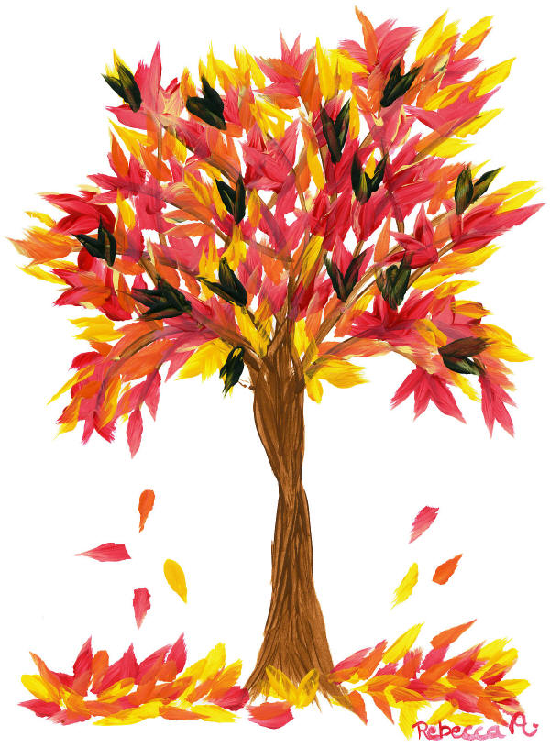

[Recipient]

6535 South Trotter Road, Clarksville, MD 21029  
410-313-7057 (phone)   
410-531-5105 (fax)

410-313-7060 (guidance)

410-313-5610 (health)

We hope you enjoyed reading our school newspaper. The next edition will come out around late January to early February. Check on the school website (cms.hcpss.org) for extra information.

The 6th grade newspaper team

* Nataile Cho
* Sabrina Dineshkumar
* Krisana Goel
* Cruz Hanson
* Naomi Hess
* Amy Li
* Sanam Patel
* Megan Rabe

Written By

Thanks for Reading

Fall 2012

The Clarksville comet

Questions and Comments?

Email us at [clarksvillecomet@gmail.com](mailto:clarksvillecomet@gmail.com)

Bye for now!