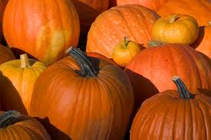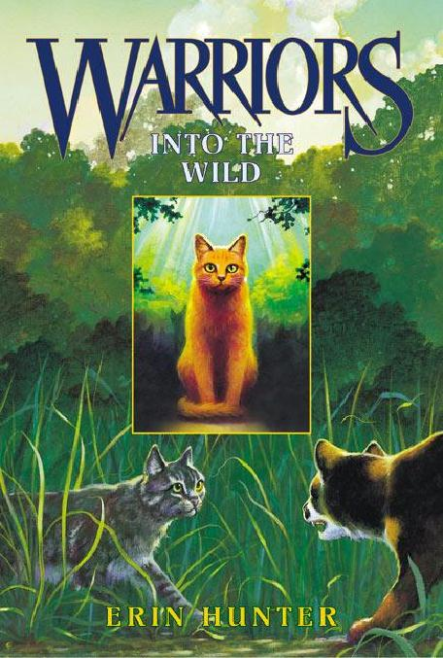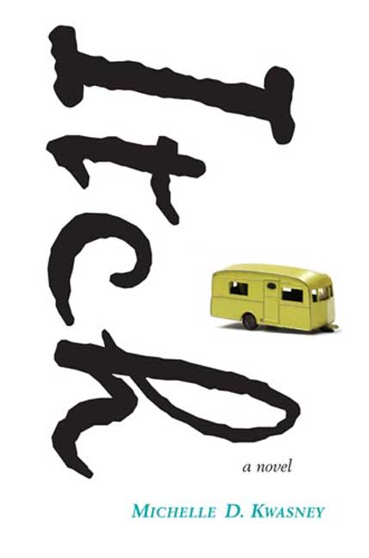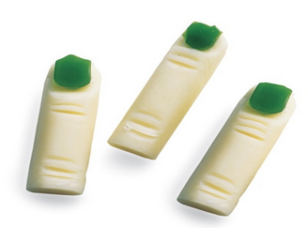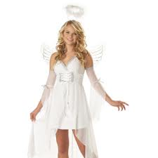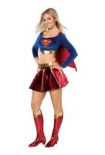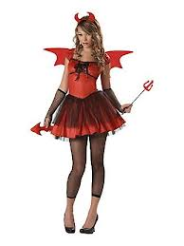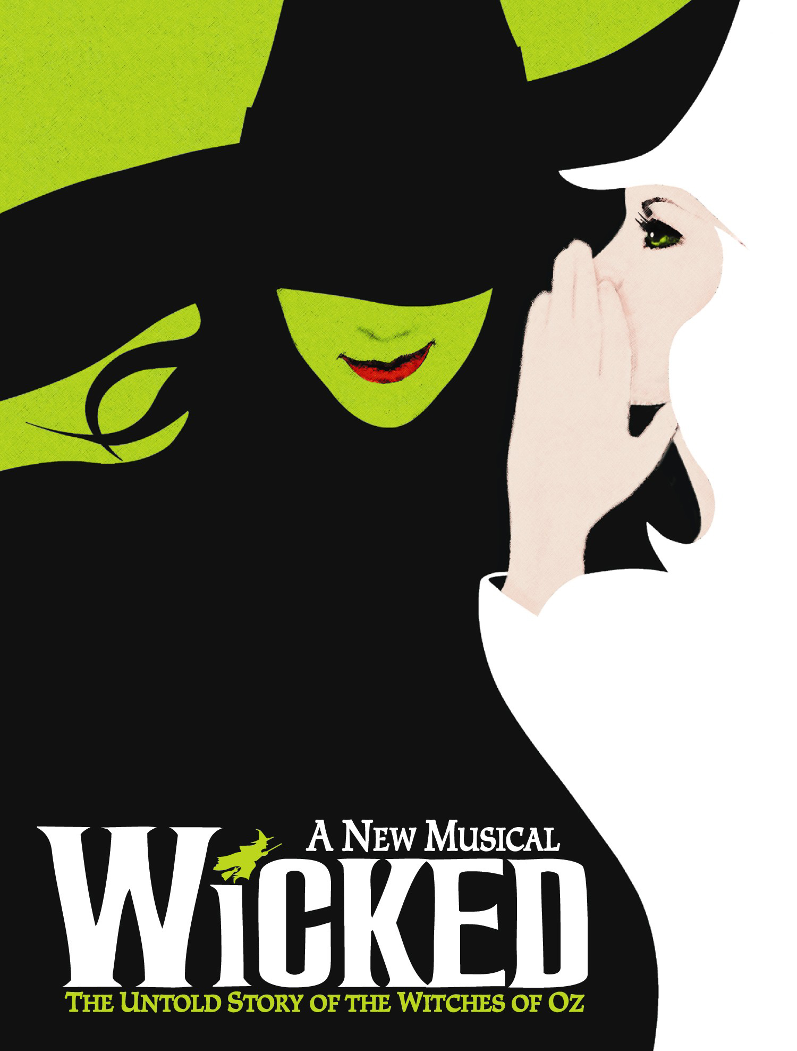

**Antidisestablishmentarianism (n),**

-pronounced

ANTI-dis-ESTABLISHMENT-arian-ISM

 In the 19th century, some British politicians had begun to conclude that the linkage of church to state was abad idea and they became known as disestablishmentarians.

Eventually, other politicians opposed this and then became known as antidisestablishmentarians. So the word means someone who opposes disestablishmentarianism.

### **Word of the Month!**

### Joseph Adrian

A day to give thanks, the anniversary of the Pilgrims’ feast.

Page 1: Introduction/Word of the Month

Page 2: Book reviews

Page 3: Style/Recipe

Page 4: Entertainment

Page 5: Teacher Survey

Page 6: Conclusion

# Table of Contents

October/November, Edition 1

Edited by: Amy Li

### the

Clarksville Core

fall 2012

A day spent with family, commonly celebrated by gift-giving.

A day celebrated by trick-or-treating and many other spooky traditions.

10/13/12

11/22/12

12/25/12

##### Halloween

##### Christmas

##### Thanksgiving

#### Save the Date!

As the co-writer of this column, I’d like to give you a book I don’t think you’ve ever heard much of, something fresh to read. Now, I’m also included in this crowd, as I’d never heard of this book before either. The book I’m reviewing, titled “Itch”, was a book randomly picked up in the library.

The main character of the story, whose nickname has been Itch ever since she got a bad case of poison ivy, hence the title of the book, lives with her grandparents in a trailer in Florida. But when her grandfather dies, she and her grandmother move to Ohio. There, Itch, who’s been afraid she won’t fit in, gets a new friend- Gwendolyn. At first, Gwendolyn seems perfect- smart, pretty, the works, and Itch’s happy to be friends with her. But Gwendolyn has a dark secret, which Itch soon discovers. One little secret can send everything tumbling down, and a big secret is even worse. How can Itch set things right if she’s afraid to speak up? Find out in Itch, by Michelle D. Kwasney.

Itch by Michelle D. Kwasney

-Rebecca Blank

Warriors: Into the Wild by Erin Hunter

-Emily Wang

WARNING: MAY CONTAIN SPOILERS

Knowing only of the comfort and protection of his home, Rusty has never wandered far beyond the fence. A vivid dream urges him to the forest, he encounters what the other kittypets call a “wildcat,” a cat rumored to live in the woods. When he is offered a chance to train with the clan and live the life of a true cat (by the clan leader herself, no less), his world changes forever.

Renamed Firepaw, he learns the ways of the wild and struggles to find his place within ThunderClan. It just so happens their medicine cat has received a prophecy that only fire can save the clan... You can kind of guess who it is. But ShadowClan, one of the four clans (ThunderClan [no duh], RiverClan, WindClan, and ShadowClan) in the forest, is frighteningly growing stronger, threatening the harmony and balance between the clans. There hides a traitor in their midst, and danger lurks around every corner. Okay, that sounded totally cliche, but it’s actually a really great book.

Filled with relentless action, once you get hooked, it’ll be hard to separate yourself from this book. The awesome thing is, *Into the Wild* is the first one in the series, so there’ll be a sequel when you’re done. And a sequel for that one. And the next, and after that too. Trust me, this story will leave you longing for more. For those of you who love fighting and blood and death, look no further. Or, at least, read this book first, and if you want to read other books afterwards, then go ahead. Best of all, it’s about CATS!! Awww... Who doesn’t love those furry little kitties? Well, these cats aren’t really the cute and snuggly type, and would probably attempt to claw your face off if you got too close... Meh.

# Book Reviews

###### Rebecca Blank and Emily Wang

**How to make it:**

1. Wearing plastic gloves over your hands to keep them as clean as possible, use a knife to cut each White Chocolate Bar in 1/3. Then, put on icing for a fingernail just below the rounded end of each bar.
2. Mark the joint right below the nail as well as the knuckle joint by carving out tiny horizontal wedges of chocolate, as pictured.
3. For the fingernails, slice a fruit roll-up into 3/8-inch-wide strips. Set the strips on your work surface. Put Fruit roll-ups on icing and put the fingers in the fridge for about 20 minutes.
4. Now take out and enjoy!!!

We are not responsible for any “accidents” that may occur.

# Recipe

# Krisana Goel and Natalie Cho

Since we are in middle school, you don’t have to go all out for a Halloween costume. You can be something or someone easily, like an angel, devil or even a superhero. You can make these costumes in a fashionable way.

Let’s start with an angel costume. For an angel costume, you have to wear white pants and a white shirt. To make it less plain, you can get angel wings from: JoAnnes fabric shop, Michaels Craft Store, and also at Party City. Also, to make it your costume prettier and more noticeable add a nice sparkly necklace and there you have it you have an easy fashionable Halloween costume.

To be a devil, you need to wear red or black. You can buy a pitchfork from: JoAnnes fabric shop, Michaels Craft Store, or at Party City. For accessories, you can get a necklace or earrings with spikes.

HAVE FUN MAKING A HALLOWEEN COSTUME!

# Fashionable Costumes

# Nairi Andonian

## Wicked: The Musical

## Naomi Hess

You have probably seen the Wizard of Oz. But have you ever wondered what made the Witch of the West evil? Wicked: the Musical shows how Elphaba, the Wicked Witch of the West, started off. She goes to a college in Oz where she meets Galinda, who eventually changes her name to Glinda and becomes the Good Witch of the north, traveling in a giant bubble. At first Galinda and Elphaba hated each other, but they became best friends. They get the opportunity to go study with the famous Wizard of Oz in the Emerald City. That’s when everything changes! Not only does Wicked show how the Witch came to be, it also shows how other popular characters such as the Scarecrow, Tin Man, and Cowardly Lion started off too. Wicked is playing at the Hippodrome in Baltimore until November 4th, so get your tickets now!

In early September, the newest version of Apple’s iPhone came out. It is 18% thinner, 20% lighter, and has 12% less volume. It has a 4-inch Retina display, which means the screen is more vibrant. The iPhone 5 comes with new earbuds, Siri, and of course, has ios6. ios6 is the new version of the Apple operating system. Anyone with an iPhone, iPod Touch, or iPad can download the new update. The features include:

* a new map system, which isn’t as good as the usual Google Maps
* FaceTime over cell network
* iCloud, which syncs data between Apple devices
* PassBook, a new built in virtual “wallet”
* offline reading on Safari
* Redesigned stores (App Store, iTunes Store, and iBooks store
* New features for Siri: restaurant reservations, movie reviews, and sports scores

and many other cool features!

The iPhone 5 starts at $199 for 16GB, $299 for 32GB, and $399 for 64 GB. Will you be getting one?

P.S: The iPad Mini is rumoured to come out on October 23. More details will come next month!

## iPhone 5

## **Naomi Hess**

# Entertainment

# Teacher Survey

# **Christine Kwon and Sanam Patel**

**1) What is your favorite color?**

    Bright Colors, Crayon Box Colors

**2) How many years have you taught at CMS?**

   18 or 19 years

**3) What is your favorite football team?**

   Baltimore Ravens (DUH!!!!)

**4) Where do you like to go for vacation?**

  (Back to) Alaska

**5) Favorite band? Type of music?**

  The Beatles and Kenny Chesney, Classic Rock and Country

**6) What is your favorite movie?**

   The Lord of the Rings (Series)

**7) Favorite book?**

  In Death Series by J.D. Robb

**8) Any advice for students?**

  DON’T TRUST PEOPLE WHO GIVE TOO MUCH ADVICE!!

**9) Any disagreements with anything?**

  Doesn’t like late lunch (7th Grade)

**10) If you had to have an exotic animal, what would it be?**

    Sugar Glider (Had one when she was a kid)

**11) Favorite food?**

    Pizza

**12) Do you like the new schedule?**

    Liked block schedule because of Science (Easier to do labs and such),

   but likes seeing everyone everyday!

   Likes having only 2 periods (classes) after lunch.

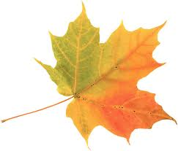

* Sam Karkowski
* Krisana Goel
* Natalie Cho
* Naomi Hess
* Kira Thompson
* Michael Wyman
* Christine Kwon
* Sanam Patel
* Emily Wang
* Rebecca Blank
* Joseph Adrian
* Nairi Andonian
* Amy Li
* Mr. Herdman

Bye for now,

Your editor

Created by:

We hope you enjoyed this month’s edition of the school newspaper. The winter edition will be released in late December/early January.

Thanks for Reading!

fall 2012

The CLARKSVILLE core