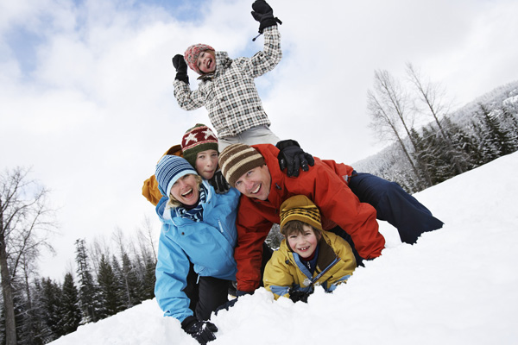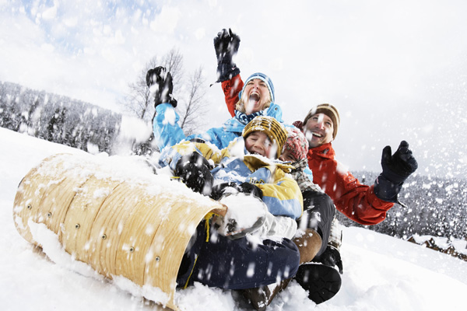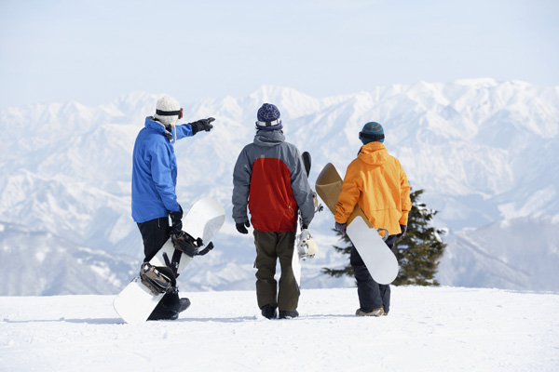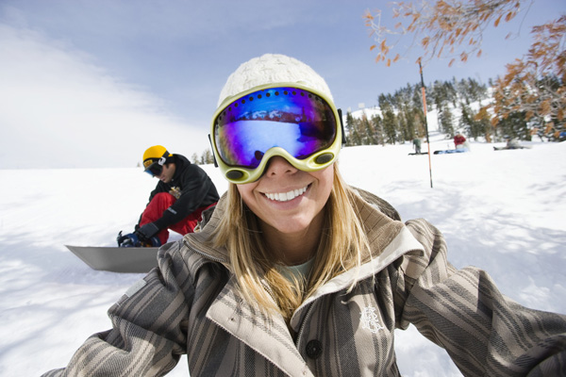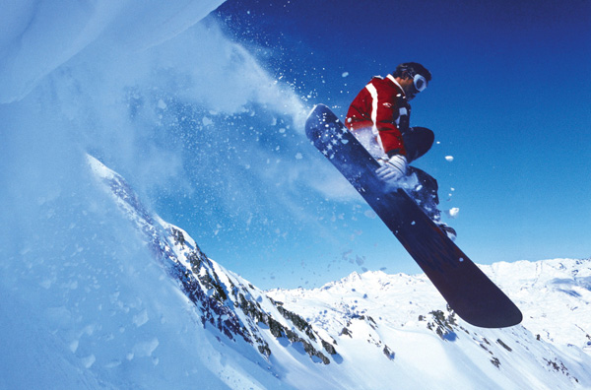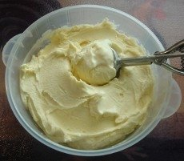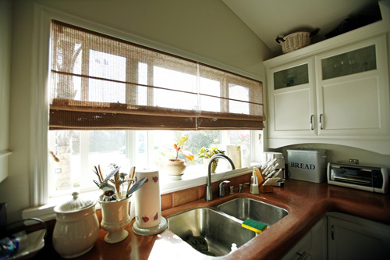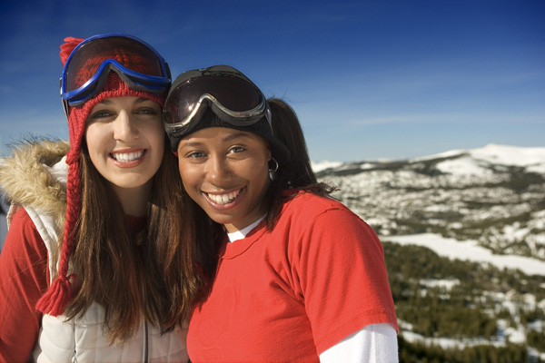

A time to get together with friends, and family to watch the Superbowl. Who do you think is going to win?

1/20/12: Leave school 3 hours early

l/30/12: Report cards issued

2/9/12- 2/10/12: Guys and Dolls Play

Integer ornare mollis sapien. Nullam imperdiet lectus nec mi.

##### Super bowl Sunday

##### Valentine’s Day

This occurs on the first day of the Chinese Lunar calendar. Families gather for a reunion dinner and celebrate. Red clothing is worn to ward away evil spirits and bad fortune. New clothing symbolizes starting the year anew.

2/14

1/23

2/5

##### Chinese/Lunar New Year

#### Holidays Coming Up This Month

In sodales. Sed suscipit. Nulla facilisi. Vestibulum nisl orci, dignissim eu, bibendum et, porttitor at, massa. Integer justo dui, pulvinar quis, eleifend eget, dictum sit amet, urna. Pellentesque sit amet ante. Sed vitae nibh ac quam scelerisque rhoncus. Quisque dapibus eros sit amet sapien. Donec blandit metus eget ante. Sed sed tellus a mi laoreet bibendum. Aliquam dictum vehicula lacus.

### Important Events

Edition 3

the

# Table of Contents

Winter 2012

What are your predictions for the 2012 football playoffs? We all know the Steelers are going to win! Hopefully the Ravens and the Steelers lay each other.  Who is going to win if they verse each other?  In the NHL the flyers went up against the Rangers in the NHL winter classic!  The Rangers won in a 3-2 victory with the Henrik Lundqvistin the goal. (HENRIK LUNDQVIST IS A GOALIE!!)

FLACCO BEAMS IT TO ANQUANBOLDIN…. BOLDIN CATCHES IT TOUCHDOWN BALTIMORE!!!!!!

Sports

By: Cruz Hanson

1.Black boots

2.Large Brown Bag

3.Jeans or Jeggings

4.Large sunglasses

5.Loose, flowing tops

6. Silver or Gold Bracelets

4.

5.

7.

8.

9.

10.

6.

# Style

## Top 10 Celebrity Street

###### By: Krisana Goel

Cras mauris lacus, eleifend vitae, facilisis vitae, tempor non, ligula. Cum sociis natoque penatibus et magnis dis parturient montes, nascetur ridiculus mus. Maecenas lobortis. Maecenas leo elit, sagittis vitae, mattis id, placerat vel, urna. Aenean interdum sollicitudin elit. Nullam rutrum pede id nibh. In mattis tempor felis.Nulla congue, mi a elementum eleifend, tellus nisl convallis lectus, id eleifend lorem ligula sit amet arcu.

Etiam quis tortor

Cras et odio vel dui tempus varius. Sed nec orci. Sed tincidunt pede a magna. Nullam tortor. Sed nulla massa, adipiscing sit amet, fermentum ut, commodo ac, turpis. Morbi sollicitudin, augue at viverra dictum, dolor nisi volutpat urna, in laoreet velit sapien in orci. Fusce sit amet odio vel lacus bibendum adipiscing.

Nulla aliquet lacinia velit

Nulla aliquet lacinia velit

# Entertainment Section

###### By: Naomi Hess

Cras mauris lacus, eleifend vitae, facilisis vitae, tempor non, ligula. Cum sociis natoque penatibus et magnis dis parturient montes, nascetur ridiculus mus. Maecenas lobortis. Maecenas leo elit, sagittis vitae, mattis id, placerat vel, urna. Aenean interdum sollicitudin elit. Nullam rutrum pede id nibh. In mattis tempor felis.Nulla congue, mi a elementum eleifend, tellus nisl convallis lectus, id eleifend lorem ligula sit amet arcu.

Etiam quis tortor

Mix the ingredients together in a big bowl.

Serves about 10 people

Ingredients

* 8 cups of fresh snow
* 14-ounce can of sweetened condensed milk

# Recipe for Snow Ice Cream

###### By: Amy Li

Would you like to know what’s going on in other seminars? Well one of the other seminars I’m in is green school. In green school we have done a few extraordinary things. So far we have planned for a reading garden just outside of the reading center, you can snuggle up with a great book or just get some fresh air! The girl scouts have also planted a Red Bud tree in the circle with the flagpole. In addition to all this fun stuff we have renovated to make this school a nicer place. We are starting to put up energy saving posters, in hallways and on the announcements. SAVE ENERGY!!!! A cell phone recycling drive will be beginning soon, so get all of your old cell phones ready to bring in to school. Keep an eye out on the announcements for more rules regarding the drive.

Green School Info

By: Krisana Goel

Sometimes you can only find slushy, dirty snow. You can still make this:

1) Fill a large bowl halfway with snow.  
2) Add 6 tablespoons of salt to the snow.   
3) Mix together:

1/2 cup half and half

1 tablespoon sugar

1/2 teaspoon vanilla extract

inside a quart-size freezer bag.  
4) Make sure all the air is out of the bag and seal it.  
5) Place the bag inside the bowl.

6) Squeeze the bag until you freeze the ice cream.

7) Remove the bag of ice cream, open it up, and enjoy!

Using Snow to Make Ice Cream

## Curabitur in dolor

Proin tempor, nunc sit amet scelerisque vulputate, urna leo laoreet nunc, posuere ultricies ipsum ligula a odio. Nunc convallis magna eget lacus. Curabitur condimentum, mauris placerat sagittis ullamcorper, purus orci rutrum mi, sit amet convallis dolor urna id tortor. Sed a lectus. Suspendisse potenti.

Nunc viverra, tellus id sagittis accumsan, justo sapien hendrerit orci, sit amet semper eros urna a mauris. Aenean felis ante, fringilla vitae, pretium nec, tincidunt nec, dolor. Suspendisse id turpis. Maecenas quam lectus, imperdiet sit amet, volutpat eu, tincidunt rutrum, turpis.

## Curabitur vitae erat

## Vivamus fringilla

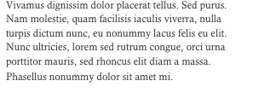

Favorite Color: Blue

Favorite Food: Brick oven pasta or fresh pasta

Favorite TV Show: GLEE ☺

Favorite Holiday: Thanksgiving

Favorite NFL Football Team: Ravens

Favorite Baseball Team: Phillies

Favorite Book: The last one I just read

Favorite Movie: Dead Poets Society

Favorite Animal: Kitties

Favorite Season: Spring

Favorite Time of Day: Evening

Favorite Restaurant: Laurienzo’s in MtAiry

Favorite Candy: My grandmom’s peanut butter chocolate fudge or snickers

Pet: 2 cats

Years Teaching: 19 years

Can you guess who this teacher is by using the facts below? Email your answer to [clarksvillecomet@gmail.com](mailto:clarksvillecomet@gmail.com) to win a prize!

Teacher Survey

By: Amy Li

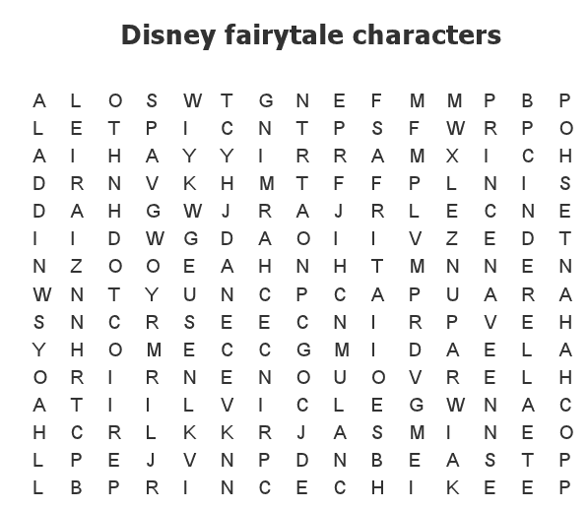

By: Krisana Goel and Sanam Patel

Word Search

http://www.farmersalmanac.com/long-range-weather-forecast/northeast-us/

**January 2012**  
**8th-11th.** Fair skies.  
**12th-15th.** Stormy, then fair, mild weather.  
**16th-19th.** Showers Mid-Atlantic region. Light snow and rain New England.  
**20th-23rd.** A chance of rain or snow.  
**24th-27th.** Storminess from the Southwest brings a dose of snow.  
**28th-31st.** Showery, especially for Mid-Atlantic.

**February 2012**  
**1st-3rd.** Rain, then fair, cold conditions.  
**4th-7th.** Increasing clouds, cold.  
**8th-11th.** Wet snow mixed with rain Mid-Atlantic north through New England; slushy accumulations of 4+" possible.  
**12th-15th.** Light snow, then fair skies.  
**16th-19th.** Unsettled.  
**20th-23rd.** Heavy wet snow sweeps up through Mid-Atlantic across the rest of Northeast, 12+" possible; then fair, cold.  
**24th-29th.** Spotty light snow/flurries; could turn steadier, heavier over eastern New England.

**March 2012**  
**1st-3rd.** Light snow/flurries. Steadier, heavier snows along New England coast.  
**4th-7th.** Stormy, with significant snow accumulations possible Mid-Atlantic region, then clearing.

The Farmer’s Almanac

By: Sabrina Dineshkumar

Thinking About Summer

Don’t you just want to throw on a T- shirt and shorts right now? Well, for me the closest thing to that is remembering the fun I had in the summer of 2011. That summer was amazing for me! I had an end of the school year party at my house, 10 girls can make a lot of noise! Next, I went to sleep away camp for the first time, and for 3 weeks! I had a blast and made a lot of new friends. The week following that I went on a cruise with the whole of my dad’s side of the family. There were 8 kids and 8 adults. I went swimming with sea turtles, canoeing, and I went to the beach. Following that awesome family cruise I went to music camp. I had a lot of fun writing my own songs and learning to edit them. Lastly and obviously the best part of my summer was the WOG Olympics. WOG stands for the initials of my street. The Olympics is where the kids on my street make a fake Olympics. We do the long jump, sprinting, long distance running biking, jousting, and gymnastics. The things we have done in the past are swimming (running down drive ways with hoses sprayed on us) and wrestling (people kept getting hurt). What a great summer!!!!!

# Author’s Note

By: Krisana Goel

We hope you enjoyed reading this edition of the school newspaper. The next edition will come out around February. Look on the school website (cms.hcpss.org) for more information. https://docs.google.com/spreadsheet/viewform?hl=en_US&formkey=dEpLaVRaQkozSU8wNTVQeUFEUEVDNmc6MQ#gid=0

Go to https://docs.google.com/spreadsheet/viewform?hl=en_US&formkey=dEpLaVRaQkozSU8wNTVQeUFEUEVDNmc6MQ#gid=0https://docs.google.com/spreadsheet/viewform?hl=en_US&formkey=dEpLaVRaQkozSU8wNTVQeUFEUEVDNmc6MQ#gid=0https://docs.google.com/spreadsheet/viewform?hl=en_US&formkey=dEpLaVRaQkozSU8wNTVQeUFEUEVDNmc6MQ#gid=0https://docs.google.com/spreadsheet/viewform?hl=en_US&formkey=dEpLaVRaQkozSU8wNTVQeUFEUEVDNmc6MQ#gid=0https://docs.google.com/spreadsheet/viewform?hl=en_US&formkey=dEpLaVRaQkozSU8wNTVQeUFEUEVDNmc6MQ#gid=0

C:\Users\jeffli\AppData\Local\Microsoft\Windows\Temporary Internet Files\Content.IE5\1OHQWA1Q\MC900336061[1].wmf

Questions or Comments?

Email us at [clarksvillecomet@gmail.com](mailto:clarksvillecomet@gmail.com)

Written By

The 6th grade newspaper team

* Natalie Cho
* Sabrina Dineshkumar
* Krisana Goel
* Cruz Hanson
* Naomi Hess
* Amy Li
* Sanam Patel
* Megan Rabe

[Recipient]

6535 South Trotter Road, Clarksville, MD 21029  
410-313-7057 (phone)   
410-531-5105 (fax)

410-313-7060 (guidance)

410-313-5610 (health)

Thanks for Reading

Bye for now!

Winter 2012

the clarksville comet

The Clarksville Comet

Mr. Herdman, Triad Room  
Clarksville Middle School